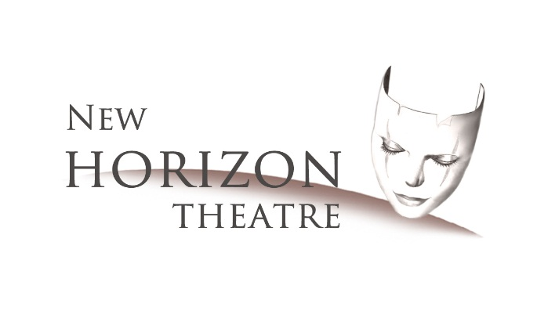
Registration Form for New Horizon Theatre’s
2021 Summer Performing Arts Camp
June 21st – 25th 9am – 4pm ET
(Show Times TBD on Afternoon/Evening of Saturday, June 26th)
Email To: hwheelerNHCT@yahoo.com (or) Mail To: PO Box 131, West Point, GA 31833

Participant’s Name: ____________________________________________________________________
Preferred Name: ________________________________________ Gender: ____________
Address: _____________________________________________________________________________
_____________________________________________________________________________
Age: __________________ Date of Birth: __________________ Grade Entering in Fall: ______
Allergies/Medical Notes:________________________________________________________________
Is this participant a BEGINNER (or) INTERMEDIATE (or) ADVANCED in Performing Arts? (Circle)
How did you hear about the NHCT Camp? __________________________________________________
Parent’s Name: _______________________________________________________________________
Parent’s Address: _____________________________________________________________________
Phone #: _______________________________ Cell #: _________________________________
Work #: ________________________________ Email: _________________________________
Emergency Contact/ Phone Number: ______________________________________________________
Required by end of registration session on Day 1 of camp: (To be completed by NHCT registration staff)
(Registration from 8:15-9:00am on June 21st – Forms can be mailed/emailed in early to avoid delays.)
Completed Registration Form for each participant
Signed Release Forms
T-Shirt Order Form
Signed Rules & Expectations Form
Payment in Full (Checks should be made to “New Horizon Theatre” - $200 for one camper/ Family discounts are available for siblings)
On back of form or extra paper, please note previous experience in Performing Arts – including music, drama, dance, gymnastics, technical, etc:

